

BOOK PRINT ARCHIVE
Use Case: Manage Titles
Use Case ID: BPA-UCS003

Version 2.0
Date: 12/16/2013

Document History
Revision Date | Version Number | Author | Comments
08/16/2013 | 1.0 | Shilpa Bhat | Initial draft
08/19/2013 | 1.1 | Shilpa Bhat | Edit following Use Case Walkthrough
08/23/2013 | 1.2 | Shilpa Bhat | Edit to Reassign Title Section based on Business Request; Updated Manage Title Normal Flow
08/23/2013 | 1.3 | Sunanda Mondal | Wireframes removed as detailed information will be provided in UI Spec
08/29/2013 | 1.4 | Sunanda Mondal | Manage WIP use case : Delete function added to Production user
09/04/2013 | 1.5 | Shilpa Bhat | Added validation during title creation for-  - ISBN’s which already have titles  - Key Metadata fields from Coltrane
09/26/2013 | 1.6 | Shilpa Bhat | Edit following comments from TCS
09/30/2013 | 1.7 | Shilpa Bhat | Added Filter functionality (Relevant to Iteration 2)
10/30/2013 | 1.8 | Shilpa Bhat | Updated NF, EF #01, EF #04 (Request New Title); Updated AF #04 (Manage WIP Title)
11/21/2013 | 1.9 | Shilpa Bhat | Added EF #04 Concurrent User – New Business Requirement
12/16 | 2.0 | Shilpa Bhat | Updated Iteration 3 requirement for Reassign Title

Introduction
The “Manage Titles” use case package is detailed and decomposed into two uses cases: “Request New Title” and “Manage W-I-P Title”. The Manage Titles use case describes the feature which allows the user to create and manage an ‘open’ or WIP Title placeholder in the content repository that is waiting on the requested content from the vendor. Once the WIP Title placeholder is created in the repository, the user has the option to request content be added to the repository. (Refer to BPA-UC005 – Manage Title Content Request)
The use cases describe only the functional requirements. This approach facilitates requirements traceability and development of test cases. For each use case, a general description is stated first followed by a detailed preferred path and then associated Alternate flows. A use case diagram is also included to facilitate the comprehension and preparation for detailed design that initiates the elaboration phase.

Associated Feature(s)
Feature ID | Title
BPA-FEAT-001 | Create Title
BPA-FEAT-002 | View WIP Title List
BPA-FEAT-009 | Delete WIP Title
BPA-FEAT-014 | View WIP Title Detail
BPA-FEAT-078 | Reassign Title

Use Case Diagram

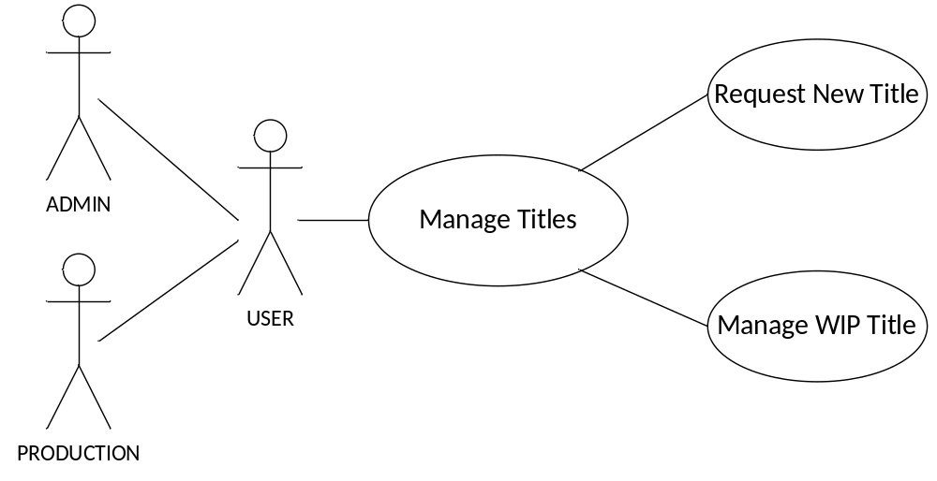

Use Case Name | Request New Title
Description | The “Request New Title” use case describes the activities that involve the need to create a placeholder for a Title in the content repository, create new edition for existing title or create title for an amended or reprint item.
Actor(s) | User (Production User or Administrator)
Assumptions | - User has login permissions to access the Manage Title feature.  - User has been successfully authenticated by way of Single Sign-on (SSO) authentication. SSO supports authentication of user credentials against an LDAP or Active Directory server.
Pre-Conditions | - User has successfully logged into BOOK PRINT ARCHIVE application
Post-Conditions/  Acceptance  Criteria | Success:  - User is able to successfully create a ‘new’ Title in the repository.  - Newly created WIP Title displays in the WIP Title List (inventory)  Failure:  WIP Title does not display in WIP Title List (inventory) because Requester was not able to create ‘new’ title.
Triggered By | User has initiated an attempt to create title from Homepage menu or via Quick Launch.
Priority | HIGH

Normal Flow
The flow of events describes the interaction between the User and the application when the User attempts to “Create a New Title” for an ISBN that has not been archived.
# | ACTOR ACTION | # | SYSTEM RESPONSE
3.1 | User chooses to request a new title by selecting ‘Create New Title”.  - AF #1 New Edition Title | 3.2 | System executes the create_new_title_request by rendering the New Title form and prompts user to enter the following information-  - ISBN (Mandatory)  - Publication Type (Set to Default)
3.3 | User enters details and submits a create_ new_ title_ request and chooses to save entries after completing the form  - AF #2 Archived Title  - AF #3 Quit Task | 3.4 | - System verifies new title request information (ISBN) against existing WIP Title list to ensure that title for the ISBN doesn’t already exist.  - System retrieves the metadata information for the entered ISBN from Coltrane and checks if ISBN, Title and Author Name fields from retrieved information are not missing.  - System creates a place holder for the new title (Refer UI Spec)  - System creates default content file structure (Refer BR 1)  - System updates WIP publication list to include the new title.  - System prompts user “Title Record successfully created”  - System opens the newly created title and displays the first step in Request Management workflow (Refer UC 005 and UC 006 for workflow) (Iteration 2)  - EF #1 Incorrect Entries  - EF #2 Existing ISBN  - EF #3 Missing Metadata
3.5 | Use Case Ends

Alternate Flow

AF-01 New Edition Title
The flow of events describes the interaction between the User and the application when the User attempts to create a new title for an ISBN with a new edition.
# | ACTOR ACTION | # | SYSTEM RESPONSE
3.01.01 | User chooses to request a title for New edition by selecting ‘Create New Title” and indicating that the title is for New Edition (check box- Refer UI Spec) | 3.01.02 | System executes the create_new_title_request by rendering the New Title form and prompts user to enter the following information-  - ISBN (Mandatory)  - Publication Type (Set to Default)  - Create Title for New Edition (check box)  - ISBN of Previous Edition Number (Mandatory)
3.01.03 | User enters details and submits a create_ new_ title_ request and chooses to save entries after completing the form  - AF #2 Archived Title  - AF #3 Quit Task | 3.01.05 | - System verifies new title request information (ISBN) against existing WIP Title list to ensure that title for the ISBN doesn’t already exist.  - System retrieves the metadata information for the entered ISBN from Coltrane and checks if ISBN, Title and Author Name fields from retrieved information are not missing.  - System creates a place holder for the new title (Refer UI Spec)  - System creates default content file structure within Content Structure section (Refer BR 1)  - System updates WIP publication list to include the new title.  - System prompts user “Title Record successfully created”  - System opens the newly created title and displays the first step in the Request Management workflow (Refer UC 005 and UC 006 for workflow) (Iteration 2)  - EF #1 Incorrect Entries  - EF #2 Existing ISBN  - EF #3 Missing Metadata  - EF #4 Incorrect Previous Edition Number
3.01.06 | Use Case Ends

AF-02 Archived Title
The flow of events describes the interaction between the User and the application when the User attempts to create a new title for an ISBN that has been archived but is being amended or reprinted.
# | ACTOR ACTION | # | SYSTEM RESPONSE
3.02.01 | User chooses to Amend archived title or Reprint archived title and chooses to save entries after completing the form. | 3.02.02 | - System verifies new title request information (ISBN) against existing WIP Title list to ensure that title for the ISBN doesn’t already exist.  - System prompts user with message (Refer BR 02 for message) to check if user wants to create Reprint or Amended Title.  - System retrieves the metadata information for the entered ISBN from Coltrane and checks if ISBN, Title and Author Name fields from retrieved information are not missing.  - System creates a place holder for the new title (Refer UI Spec)  - System copies data associated with the archived version into the content structure.  - System updates WIP publication list to show the new title.  - System prompts user “Title Record successfully created”  - System opens the newly created title and displays the first step in the Request Management workflow (Refer UC 005 and UC 006 for workflow) (Iteration 2)  - System italicizes the corresponding Archived title to indicate that it is being amended or reprinted.  - EF #1 Incorrect Entries  - EF #2 Existing ISBN  - EF #3 Missing Metadata  - AF #3 Quit Task
3.02.03 | Use Case Ends

AF-03 Quit Task
The flow of events describes the interaction between the User and the application when the User attempts to quit operation without completing the task.
# | ACTOR ACTION | # | SYSTEM RESPONSE
3.03.01 | User chooses to exit before completing the form. | 3.02.02 | System will not save changes and quit task.
3.03.03 | Use Case Ends

Exception Flow

EF-01 Incorrect Entries
The flow of events describes the interaction between the User and the application when the User attempts to save changes with incorrect ISBN.
# | ACTOR ACTION | # | SYSTEM RESPONSE
 |  | 3.01.01 | System verifies the new title request for incorrect ISBN and prompts an error message “The ISBN you typed in does not seem to be a valid ISBN”
3.01.02 | Use case resumes at Step #3.03 of Normal Flow or Use Case Ends

EF-02 Existing ISBN
The flow of events describes the interaction between the User and the application when the User attempts to create a new title or new edition for an ISBN that has a title already in WIP list.
# | ACTOR ACTION | # | SYSTEM RESPONSE
 |  | 3.02.01 | System prompts user “A record for this ISBN already exists in BPA” and also indicates the ISBN information and who the Requestor for that ISBN is. (Refer UI Spec)
3.02.02 | Use Case Ends

EF-03 Missing Metadata
The flow of events describes the interaction between the User and the application when the User attempts to create a new title for an ISBN for which system is unable to retrieve key Coltrane Metadata information.
# | ACTOR ACTION | # | SYSTEM RESPONSE
 |  | 3.03.01 | System prompts “Metadata information is missing. Record cannot be created” and specifies which attribute (ISBN, Author Name and Title) is missing
3.03.02 | Use Case Ends

EF-04 Incorrect Previous Edition Number
The flow of events describes the interaction between the User and the application when the User attempts to create a new title for an ISBN with a new edition and the previous edition number entered is incorrect.
# | ACTOR ACTION | # | SYSTEM RESPONSE
 |  | 3.03.01 | System prompts “No information found for that Base ISBN”
3.03.02 | Use Case Ends

Use Case Name | Manage W-I-P Title
Description | The Manage Work-In-Process (WIP) Title use case describes the feature which allows the user to manage WIP titles contained in the repository. The Administrator is able to update, view, delete or reassign all WIP titles while the Production user has permissions to update, view and delete only those WIP titles associated with their respective user ID.
Actor(s) | User ( Production User and Admin)
Assumptions | - User has login permissions to access Manage Titles feature  - User has been successfully authenticated by way of Single Sign-on (SSO) authentication. SSO supports authentication of user credentials against an LDAP or Active Directory server.
Pre-Conditions | - User has successfully logged into BOOK PRINT ARCHIVE application
Post-Conditions/  Acceptance  Criteria | - Production User is able to successfully view a list of WIP titles associated with his/her ID, select a particular title from the WIP list and view/edit/filter or delete the item from the repository.  - Admin is able to view all WIP titles and can select a particular title from the WIP list and view/edit/filter or delete the item from the repository.
Triggered By | User has initiated an attempt to manage titles from Homepage menu
Priority | HIGH

Normal Flow
The flow of events describes the interaction between the User and the application when the User attempts to update WIP Titles.
# | ACTOR ACTION | # | SYSTEM RESPONSE
3.01 | User chooses to Update a title.  - AF #1 View Titles  - AF #2 Delete Title  - AF #3 Reassign Title  - AF #6 Filter WIP List (Iteration 2) | 3.02 | - System retrieves list of all WIP tiles for user to choose from (based per User permissions). System displays the WIP list with most recent page, filter and sort settings {WIP list is by default sort order is based on Date of Request with the newest title on top (descending order)}
3.03 | User selects title to be updated from list.  User chooses to update new title. User has the option to-  - Edit Metadata information for Title (Iteration 2)  - AF# 04 Update Amended Title | 3.04 | System edits metadata information  - EF #04 Concurrent User
3.05 | User chooses to save changes made to content structure (Iteration 2)  - AF #05 Quit Task | 3.06 | System saves title information and prompts “Title Record successfully saved”
3.07 | Use Case Ends

Alternate Flow

AF-01 View Titles
The flow of events describes the interaction between the User and the application when the User attempts to View existing Title.
# | ACTOR ACTION | # | SYSTEM RESPONSE
3.01.01 | User chooses to View all WIP titles. | 3.01.02 | - System retrieves list of all WIP tiles for user to choose from (based per User permissions). System displays the WIP list with most recent page, filter and sort settings. {WIP list is by default sort order is based on Date of Request with the newest title on top (descending order)}  - WIP list is sortable are sortable (Refer UI Spec for more details)
3.01.03 | User selects title to be view from list | 3.01.04 | System displays the title details (Iteration 2)  - EF #04 Concurrent User
3.01.05 | Use Case Ends

AF-02 Delete Title
The flow of events describes the interaction between the User and the application when the User attempts to delete existing Titles.
# | ACTOR ACTION | # | SYSTEM RESPONSE
3.02.01 | User chooses to Delete a title. | 3.02.02 | - System retrieves list of all WIP tiles for user to choose from (based per User permissions). System displays the WIP list with most recent page, filter and sort settings {WIP list is by default sort order is based on Date of Request with the newest title on top (descending order)}
3.02.03 | User selects title to be deleted from list | 3.02.04 | - System verifies whether user wants to delete title with message “You are about to delete item(s). This action cannot be undone in the future. Do you wish to continue?” (Refer UI Spec)  - System deletes title and all associated information and prompts “Title Record successfully deleted”  - System updates Titles list by removing deleted item  - EF #01 Unsuccessful Delete  - EF #04 Concurrent User
3.02.05 | Use Case Ends

AF-03 Reassign Title
The flow of events describes the interaction between the User and the application when the User attempts to Reassign Title to another User
# | ACTOR ACTION | # | SYSTEM RESPONSE
3.03.01 | User chooses to Reassign a title to another User | 3.03.02 | - System retrieves list of all WIP tiles for user to choose from (based per User permissions). System displays the WIP list with most recent page, filter and sort settings {WIP list is by default sort order is based on Date of Request with the newest title on top (descending order)}
3.03.03 | User selects title to be reassigned from list | 3.03.04 | System prompts user to select the SSO user name or <first name last name> of the person the title has to be assigned to. (Refer UI Spec)  NOTE: Business has requested that user could enter user’s first and last name in addition to SSO user name. TCS has done feasibility analysis and has agreed to include it as a part of Iteration 3  - EF #04 Concurrent User
3.03.05 | User enters SSO user ID or <first name last name> and elects to reassign title | 3.03.06 | - System verifies if user wants to reassign with message “The request might not be visible to you after you have assigned it to <<username>>. Are you sure?” (Refer UI Spec)  - System verifies if SSO user ID or <first name last name> is valid  - System reassigns title and prompts user “Request has been successfully re-assigned”  - System updates User’s WIP Titles list by removing reassigned title from list  - System updates the new user’s WIP list to reflect reassigned title and changes “Requester name” to current user  - AF #04 Quit Task  - EF #02 Invalid User
3.03.07 | Use Case Ends

AF-04 Update Amended Title (Iteration 2)
The flow of events describes the interaction between the User and the application when the User attempts to edit an Amended/reprint title.
# | ACTOR ACTION | # | SYSTEM RESPONSE
3.04.01 | User selects title to be updated from list to edit the Content structure section. User chooses to update amended title. User has the option to-  - Edit Metadata information for Title  - Delete files from Content Structure  - Change existing Content structure by adding or deleting Content Structure folders (Refer BR1 for default content file structure) | 3.04.02 | System saves the changes to the title and displays message “Title Record successfully saved”. The updated titles will display in the repository.  - EF #04 Concurrent User
3.04.03 | Use Case resumes at Normal Flow #3.05

AF-05 Quit Task
The flow of events describes the interaction between the User and the application when the User attempts to quit operation without completing the task.
# | ACTOR ACTION | # | SYSTEM RESPONSE
3.05.01 | User chooses to exit before completing the form. | 3.05.02 | System will not be save changes and quit task.
3.05.03 | Use Case Ends

AF-06 Filter WIP List (Iteration 2)
The flow of events describes the interaction between the User and the application when the Admin attempts to filter the WIP titles based on Requester Name (i.e. SSO). This feature is available only to Admin.
# | ACTOR ACTION | # | SYSTEM RESPONSE
3.06.01 | Requester chooses to enter the filter criteria. | 3.06.02 | System renders filtered WIP title list in a paginated format by performing first five characters match of Requestor Name (Refer BR 03).  - EF-03 No Filter Results
3.06.03 | Use Case Ends

Exception Flow

EF-01 Unsuccessful Delete
# | ACTOR ACTION | # | SYSTEM RESPONSE
 |  | 3.01.01 | - System is unable to delete title successfully  - System retains WIP title in list
3.01.02 | Use case Ends

EF-02 Invalid User
# | ACTOR ACTION | # | SYSTEM RESPONSE
 |  | 3.02.01 | System prompts to user “The user <<username>> could not be found in LDAP. Request cannot be assigned to <<username>>".
3.02.02 | Use case resumes at Step #3.03.03 of Alternate Flow

EF-03 No Filter Results (Iteration 2)
Description | WIP title list can be filtered based on Requestor Name. However, if filter criteria does not match with any of the search results an error is displayed

# | ACTOR ACTION | # | SYSTEM RESPONSE
 |  | 3.3.1 | System does not display any results and prompts “No Record Found”
3.3.2 | Use case returns to Step 3.01 of the Normal Flow or Use Case Ends

EF-04 Concurrent User (Iteration 2)
The flow of events describes the interaction between the User and the application when concurrent users attempt to open a WIP title at the same time.
# | ACTOR ACTION | # | SYSTEM RESPONSE
 |  | 3.04.01 | - System prompts user “Record is currently being used by <<SSO ID of user accessing record>>and cannot be accessed”.  - WIP title record is not opened and system continues to display WIP list
3.04.02 | Use Case Ends

Related Business Rules
ID | Description
BR 01 | Default Content File Structure within Content Structure section:  - Control  - Before Table of Contents  - Table of Contents  - Between Table of Contents and Preface  - Preface  - After Table of Contents/Preface  - Chapter
BR 02 | Sample system prompt to check if user wants to create Amended or Reprint title:  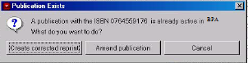
BR 03 | - Filter criteria is based only on Requestor Name (i.e. SSO)  - Filter criteria considers only first five characters of Requestor Name

UI Specification (Iteration 2)
Filter WIP List

Description
WIP titles can be filtered by Admin only by using the Filter option. WIP list can be filtered based on Requester Name (i.e. SSO). By entering filter criteria into textbox provided, user can sort WIP based on the first five characters of the Requester Name.

Navigation
To filter WIP titles:
- Enter filter criteria into textbox
- Click “Filter Result” option
- Search results are filtered based on first five characters of Requester Name entered
- Filtered results are displayed
- When filter criteria yields no results, error message prompted is “No Record Found”
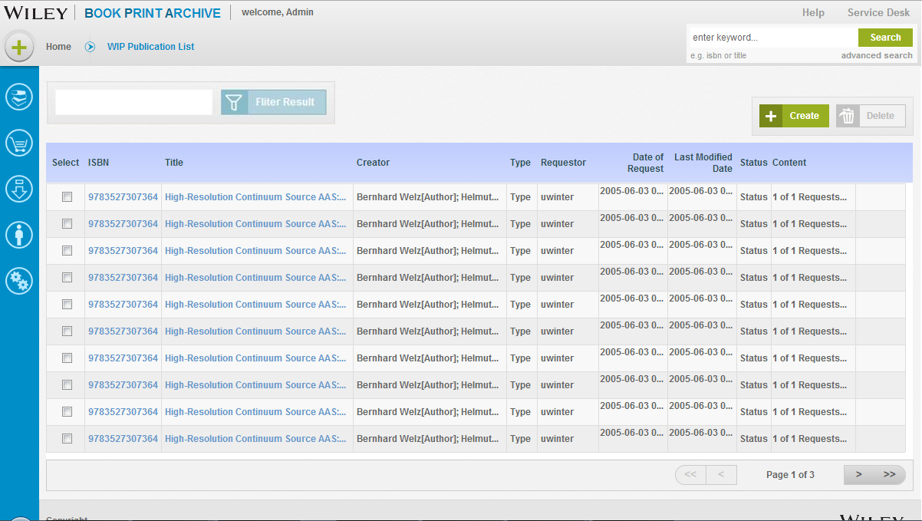
Screen Elements
Filter Result
Type: | Text box with button
Label: | Filter Result
Length: | Five characters of Requester Name
Default: | n/a
Behavior:  Values: | The WIP list is filtered to further narrow down based on the Requester name. Maximum number of character system can filter by is five.  WIP title list only

UI Specification (Iteration 3)
Reassign Title Record

Description
A WIP title record which is present in a user’s WIP list can be reassigned to another BPA user to give the new user complete control of the WIP title. Once a title has been reassigned, it will no longer be displayed in the user’s WIP list.

Navigation
User may choose to reassign a title by selecting the action button on the right from the WIP list page. On selecting <Reassign> option, users are prompted to enter the name or the SSO ID of the user to whom the title has to be assigned to. If a correct SSO ID or <first name last name> is provided, title record is reassigned to new user and the title record is removed from WIP list of old user and transferred to new user. Additionally, the “Requester Name” of the title record is updated to new user.

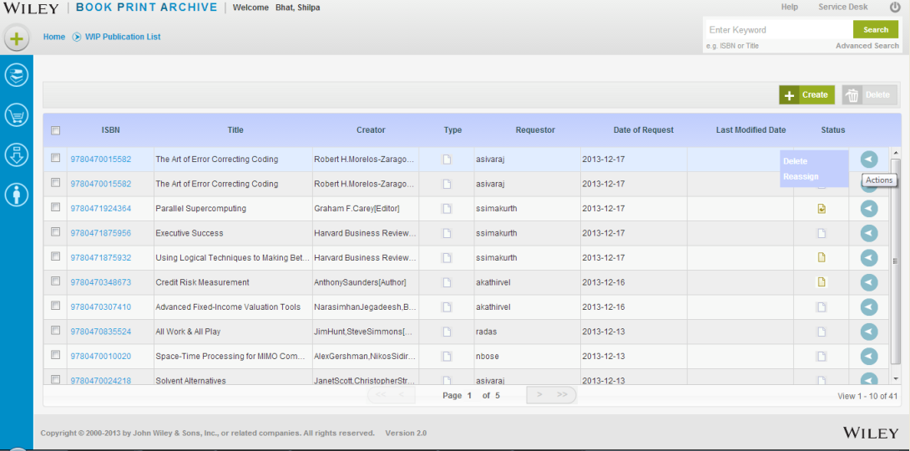

Screen Elements
Reassign
Type: | Button
Label: | Reassign
Behavior: | Once user selects a record and chooses <Reassign >button, a dialog box opens requesting the user to assign the WIP request to another user. The assigned user information can be provided by giving the user’s Single Sign on username or giving user’s (first name last name) information which is received from LDAP. Upon assigning the request to another user, a dialog box will display < The request might not be visible to you after you have assigned it to <<username>>. Are you sure? > . User can select to accept, decline or cancel the request. Once title has been successfully reassigned, a message is displayed “Request has been successfully re-assigned”  In exception case, when the assigned user information is not present in LDAP, the following message will be provided <The user <<username>> could not be found in LDAP. Request cannot be assigned to <<username>> >.

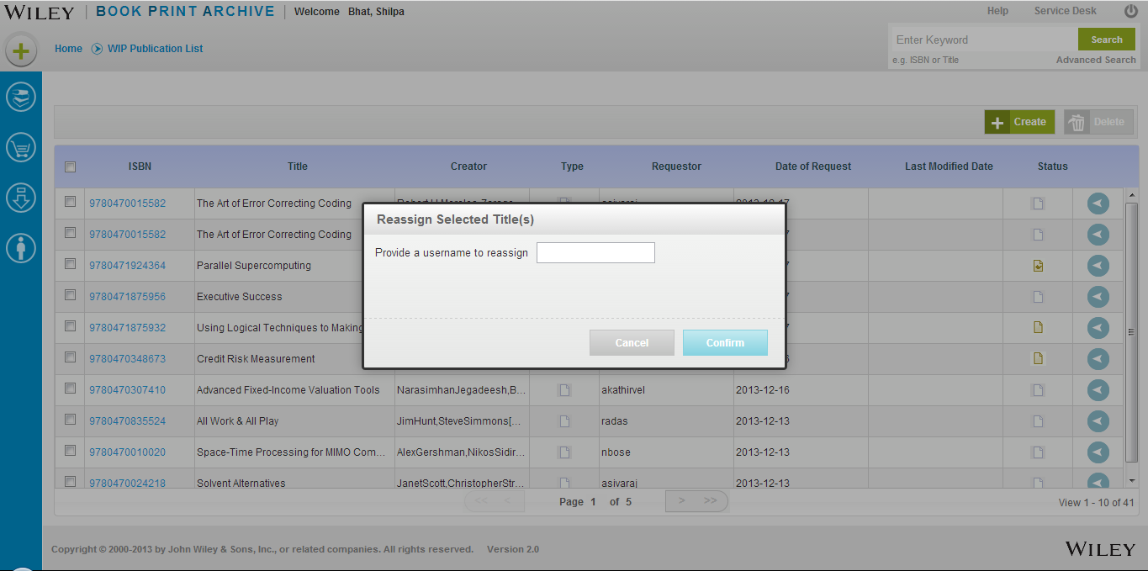
Cancel
Type: | Button
Label: | Cancel
Behavior: | Current user retains title record in WIP list
Confirm
Type: | Button
Label: | Confirm
Behavior: | Reassigns the title to new user

